Support, Activities and Organisations for Autistic and Neurodivergent children in Stockton-on-Tees and the Surrounding areas.
This document was classified as: OFFICIAL

Click on the titles below for links to more information

Autism/Neurodivergent specific support/activities
Daisy Chain Provide support and activities for children, young people, and adults who are autistic or neurodivergent, and their parents. This includes family activities, holiday and after school clubs, wellbeing support (Age 15+) and Parent support groups.

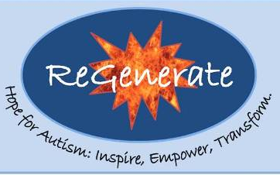
Regenerate Provide support and activities for people of all ages from early years to adulthood. Run by adults with autism who have an insight into some of the difficulties children may be experiencing. They provide activities and programmes to develop particular skills.

Autism Parents Together Is a registered charity and parent support group. They have a private Facebook group for parents to share experiences, advice etc, hold monthly coffee mornings, and organise activities exclusively for families with autistic children places such as Play Factory, Clip & Climb etc.

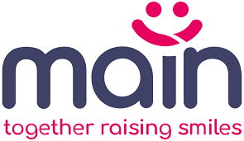
MAIN Based in Middlesbrough, Main provides clubs and 1:1 support in the community, an advocacy service, and other resources such as a lending library of sensory toys and equipment for individuals who are neurodivergent, autistic, learning disabled and or complex needs, and their families,


Autism Central aims to make it easier for parents/carers to learn more about autism and services available to them. There are online resources about many of the issues that can affect people with autism e.g. sensory differences, personal care, eating etc.


Ninja Warrior Teesside has an autism friendly quiet hour on Wednesday evenings during term time. Capped at 50 guests, 1 free carer per group, Lower music levels & no themed lighting, Sensory room including colouring books, Sensory lighting & stress toys, and autism awareness trained staff.



Sunflower Sensory Service is delivered by experienced members of the NHS Paediatric Occupational Therapy team. They provide a series of three friendly and interactive workshops called Sunflower Parent Training, help parents understand and meet their child’s sensory needs.
North East Autism Society Family Development Team have information and tips on a wide range of challenges faces by people with autism, including sensory differences, coping with trips out, puberty, diet and nutrition and more. They also have some Zoom webinars for parents

The links below are not autism/Neurodivergent Specific, but they include support for people with any disability.

Short Breaks Grant Opens every 6 months, for families to apply for funding for activities for a child with a disability. Read the short Breaks Grant offer PDF within the link to see eligibility and what it can be used for.


Stockton HAF Programme Activities for school holidays. For children with additional needs, request a call back, and they discuss the child’s needs and will advise what activities are suitable and support with booking. This sometimes includes activities at Daisy Chain and ReGenerate.


SNAPS Tees Valley organise various activities exclusively for disabled/neurodivergent children, young people, adults with and parent/carers. With term time and school holiday timetables, there is a wide variety of activities available. Children/young people must be accompanied by a parent/carer, and siblings are also able to attend. Their Facebook page is the best way to get the latest information about the activities available.
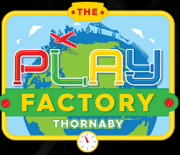
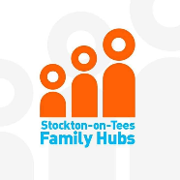
Stockton Family Hubs are about to launch a range of SEND activities. During August there will be sessions around sexual health, relationships and wellbeing, some for parents and some for young people. From September there will be activity sessions such as crafts, Lego club, sensory sessions. Details have not yet been published, but follow the Family Hubs Facebook page to find out details as they are released.

Play Factory in Thornaby has Exclusive Additional Needs sessions 9.30am-10.30am on Sunday mornings, priced lower than the usual admission rate.


Stockton Wheelers Cycling Club hold inclusive cycling sessions, approximately twice per month, for children and adults with any disability at Middlesbrough Sports Village. Using a variety of accessible cycles, with volunteers to provide support. Family members/carers are welcome to provide the support if this is better for the participant. There is no charge, just a donation box towards the cost of the sessions. Follow the Facebook page for details being published. Places need to be booked in advance.

Stockton Parent Carer Forum host coffee mornings for parents, feed back to Stockton Council on facilities and services on behalf of parents, and have a private Facebook group where parents can share experiences, information about services and activities etc. Parents report this to be a useful information and support. You will need to register on the website before you can join the Facebook Group here

Family Fund (Income based eligibility applies) provides a wide range of grant items to families in England raising a disabled or seriously ill child or young person, and living on a low-income, including computers and tablets, games consoles, family breaks, clothing, and sensory toys.

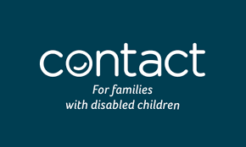
Contact for families of Disabled Children Provides information, advice and support for families on a wide range of issues, including benefits, education, preparing for adulthood and more. They also have a not-for-profit online shop selling disability and sensory specific clothing and equipment.

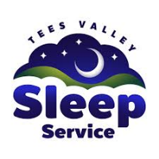
Tees Valley Sleep Service Using a tiered approach, the service provides telephone support & resources, Parent Sleep Support Sessions and 1:1 sleep assessments which, if all tiers have been accessed, can include the creation of a bespoke sleep plan. The service can be accessed by families if your child has an additional health or development need and is between the age of 2 ½ and 18 years.


Stockton's SEND Local Offer Provides information and links to many organisations where you can get help, support and activities, including short breaks and leisure activities, education, Childcare, and Preparing for adulthood. Some are autism-specific, and others are more general.


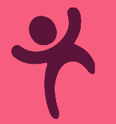
Middlesbrough Local Offer is similar to the Stockton Local Offer with some activities and organisations that are within travelling distance, and some that are in Stockton but not in the Stockton Local Offer, such as the Autism Friendly Lego Club at Billingham library.

Darlington Local Offer Same as above

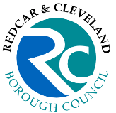
Redcar and Cleveland Local Offer Same as above

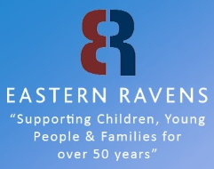
Eastern Ravens Young Carers’ Service Provides support for young carers aged 5 to 18. This includes those who support in the care of a disabled sibling and/or are isolated because of the needs of a sibling. This can include:
respite breaks - time out for young carers to meet others in similar situations, take part in activities similar to their peers such as group work to increase confidence and self-esteem
family support - help for parents and guardians, including listening ear support and signposting to other agencies and services
whole family activities - opportunities for young carers and their families to enjoy fun activities together, reducing isolation and combating poverty

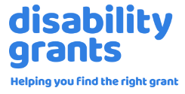
The Disability Grants Website provides links to many different organisations who offer grants for disabled children or adults, with a search function to narrow down if you are looking for a grant for something in particular.

